**Barrow upon Soar Street Market**

***Sunday 22nd June 2025 from 11am – 4pm***

***Set up access from 9,00am***

**APPLICATIONS ARE NOW OPEN!**

We are looking for a brilliant mix of stallholders and entertainment for visitors for the return of the Barrow Upon Soar Street Market

* local food/drink producers and retailers (including veggie and vegan)
* street food sellers
* handmade crafts, artwork, vintage/retro and collectables, recycled goods
* retailers of high-quality goods (plants, clothing, tools, books, jewelry, gifts
* School groups/choirs/bands
* Barrow Upon Soar or local community organisations to promote and raise funds for their causes.

**Don’t delay, contact us now & reserve your place.**

**Bookings:**

Bookings are now open, and an application pack is attached for completion. When completed please return and include a copy of your Public Liability insurance by email to the address below.

***Note: Your application, together with the non-refundable stallholder fee should be received on or before midnight on Friday 23rd May 2025.***

Only applications with completed paperwork will be accepted. All applications will be acknowledged if an email address is supplied.

**Pitch prices for 2025**

Standard 3m x 3m pitch - Non-catering food and general retail/services £20.00

Standard 3m x 3m pitch - Catering/Serving alcohol £40.00

Standard 3m x 3m pitch – Rides/games/children’s entertainment £40.00

Local charity/community organisation (Promo and fundraising) £10.00

**Larger pitches are available. Please enquire about prices.**

**Please Note:**

* Stallholders will need to provide their own power, lighting, equipment and water. No equipment is provided, only a space.
* Generators will only be allowed with confirmation agreement from the organisers.
* You will not be able to leave any vehicles on High Street. Limited parking will be available for stall holders in Station Car Park and the Co-op Car Park.
* Further details on set up times and instructions will be provided.
* It is your responsibility to manage any litter and take it away with you.
* In order to secure your space, you agree to pay stall fee by Bank Transfer on or before midnight **23rd May 2025** (If booking a space after this date, the fee is payable within 48hrs of submitting your application).
* You agree to keep the organisers up to date with any changes or requirements via email and will adhere to the rules on the day.
* You understand that the organisers are not responsible for any damages, theft or losses incurred as part of your attendance to this community event.
* Failure to comply with any of the above will result in immediate cancellation.

***Any questions please do not hesitate to contact us:*** [***clerk@barrowpc.org.uk***](mailto:clerk@barrowpc.org.uk) ***or call 01509 416016***

Your name:

Business name:

**Barrow upon Soar Street Market – Sunday 22nd June 2025**

Application Form

Business name:

|  |  |
| --- | --- |
| Your name:  Business Address: | |
| Postcode |  |
| Email | Website |
| Landline Telephone | Mobile: |
| PRODUCTS:  Please list what you intend to sell or activity: Please describe what you intend to do on your stall. | |
| **Will you be attending in person to run your stall** Yes/No *  **Will you be using any of the following:-**  **Generator:** Yes/No * **Type of fuel:** LPG or Diesel  **LPG Cooking equipment:** Yes/No * **Electrical Cooking Equipment** :Yes/No *  **Caterers: Are you registered with NCASS?** Yes/No *  *Please circle as necessary | |

|  |  |  |  |
| --- | --- | --- | --- |
| **Size/Type of Pitch** | **Please tick pitch required** | **Price** | **Total Payable** |
| **STANDARD 3m x 3m – RETAIL/CRAFT (nonfood)** | **Bringing a gazebo?**  **Y / N Size:** | **£20.00** | £ |
| **STANDARD 3m x 3m CATERING/ALCOHOL SALES** | **Vehicle type?** | **£40.00** | £ |
| **STANDARD 3m x 3m RIDES/GAMES** | **Bringing a gazebo?**  **Y / N Size:** | **£40.00** | £ |
| **Local Community/Charity (Promotional and fundraising)** | **Bringing a gazebo?**  **Y / N Size:** | **£10.00** | £ |
| **Please provide details to enquire about prices for larger pitches** | | TBC |  |

**Applicant Declaration**

* I hereby apply for a pitch at Barrow upon Soar Street Market 2025
* I have current Public Liability Insurance for the event and attach proof here with

**For food businesses**

* I am registered with .........................................................local authority as a Food Business
* I can confirm that all staff serving food have a basic food hygiene qualification or are suitably trained for the role
* If serving alcohol, I have a Temporary Event Notice.

I, the undersigned declare that the information provided on this form is correct

Signed Date

Print Name Position in Company

**Enclosures  
□ Copy of Public Liability Insurance   
□ A Risk Assessment** (template can be provided)  
 **□ Food/Caterers Questionnaire** (to be provided to Environmental Health if requested) **□ Gas Safety Certificate & PAT testing** (Caterers)

**□ Temporary Event Notice (for alcohol sales)**

***Your application will not be considered unless the relevant forms are completed and all necessary documents are enclosed/attached.***

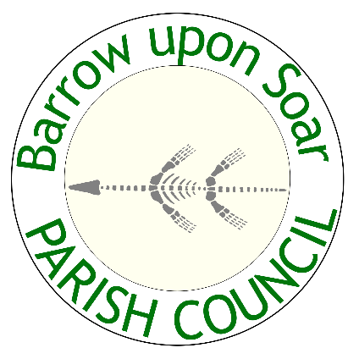

**PAYMENTS**

**All payments should be made to the account below and all fees are non refundable.**

Lloyds Bank:

Sort code: 30 95 21

Account No: 00748059

**Please use your business/ organisation name as the payment reference. If you are enquiring about a larger or different pitch space, please DO NOT send a payment until your pitch price has been confirmed.**

Please return to:  
**Email: clerk@barrowpc.org.uk**